**FREE Electronic & Audio Book Resources**

1. [**Audible Stories:**](https://stories.audible.com/discovery)

Free audio stories for kids available at this site through Audible. You don’t even need to create an account to access the books!

1. [**MidAmerica (Abdo) Books:**](https://abdodigital.com/?tk=414F33301B8E136DEE3F0A93BF1795E1)

Free access to all of MidAmerica’s thousands of ebooks and their databases through June 2020. No username/password is necessary.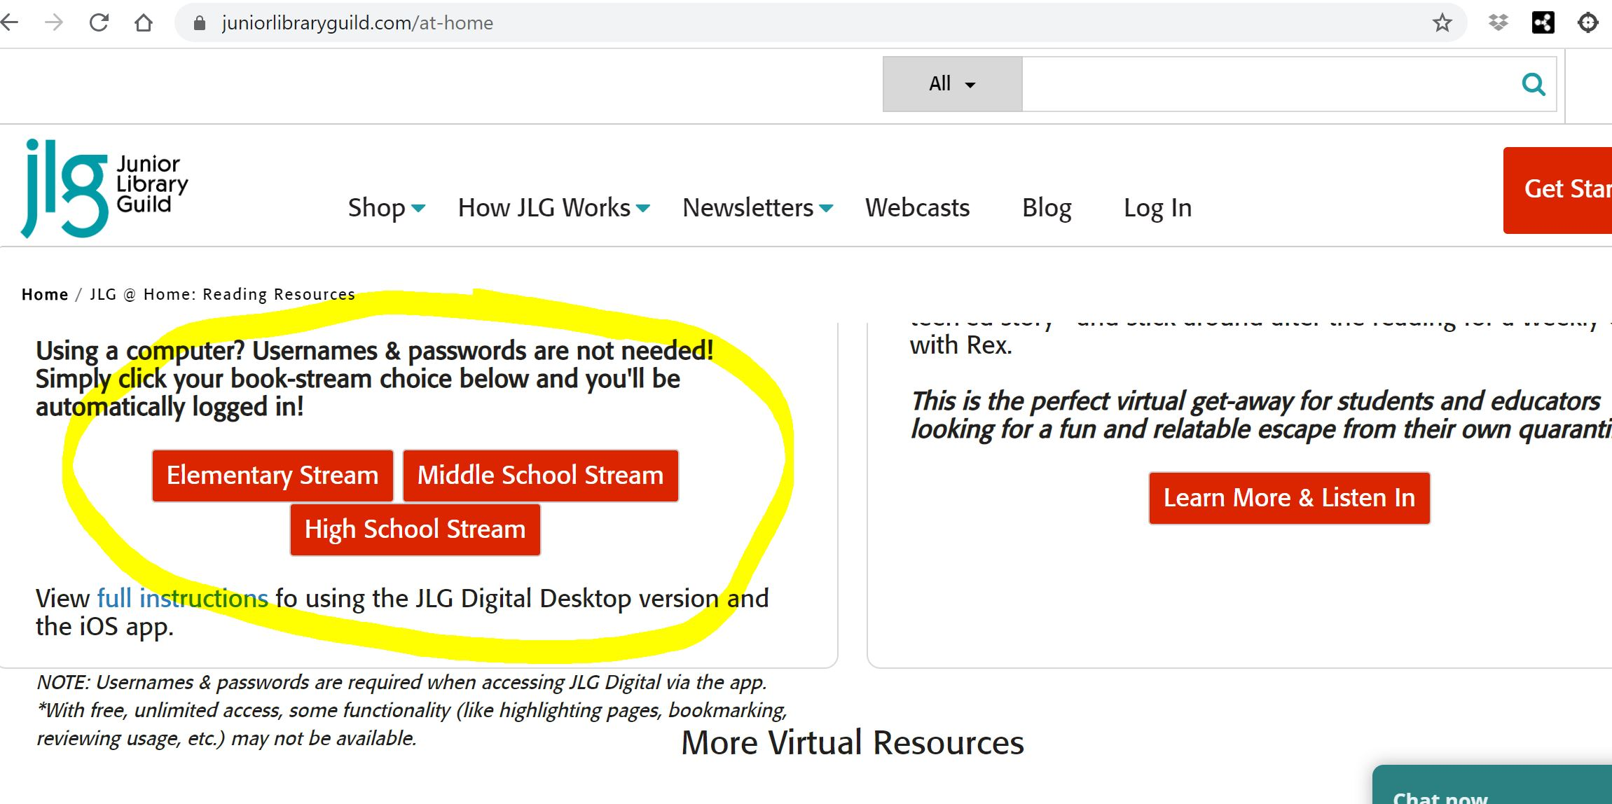

1. [**Junior Library Guild At Home**](https://www.juniorlibraryguild.com/at-home)

Free unlimited access to ebooks on their website. No username or password is needed. Simply scroll down and click the school-level book stream of your choice and you'll be automatically logged in! (see the graphic)

**4.** [**My Capstone Library**](https://www.mycapstonelibrary.com/login/index.html)

The perfect [Capstone Interactive eBook](https://www.pebblego.com/free-pebblego-capstone-interactive-access-school-closures) is waiting for you! Choose from different subjects, genres and levels to find just the right book. And every title is supported by audio recorded by professional voice-over artists!

Username: continue Password: learning

**5.** [**Follett DestinyDiscover**](https://search.follettsoftware.com/metasearch/ui/68994)

Follett is providing free access to Lightbox & AV2 interactive electronic books

Username: guest

Password: follett

**6**[**. AR myONLogin**](https://www.myon.com/school/readathome)

This is the Accelerated Reader online database. It includes thousands of engaging digital books for both online and offline reading. Students also have access to daily news articles written just for kids and published in both English and Spanish.

School Name: Read at Home

Username: readnow

Password: myon

**7.** [**TumbleBooks**](https://www.tumblebooklibrary.com/Home.aspx?categoryID=77)

Good news…the Ocean County library has more options for remote learning thanks to TumbleBooks! Through August 31, 2020, enjoy e-books, e-audios, videos and more without a library card and PIN. Options available for all ages, too!

**8.** [**Vooks (elementary)**](https://www.vooks.com/)

Teachers can sign up for one year of free access to the animated storybook database.

**9**[**. World Book Online**](https://www.worldbookonline.com)

Free access to all their resources. Log in using the information below and then click on e-books.

Username: wbsupport

Password: distancelearn

**10.** [**Loving2Read**](https://loving2read.com/books/?fbclid=IwAR0XOTFgT-zQUwQGEFc-5s-JLJxNpjV7cfCEakpHTk8F6T_XjJUlg4AjuZ0)

This web site gives access to outstanding, inspirational, educational books. No username or password is required.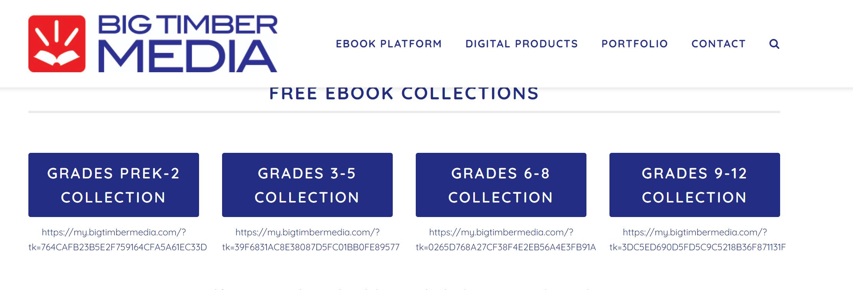

**11.** [**Big Timber Media**](https://www.bigtimbermedia.com/distance-learning-bundles/?utm_medium=email&utm_source=subscribers&utm_campaign=free-bundles&fbclid=IwAR0_udS0YoXXF-5-l32olTBC9gIryLqyOUiBnw4_jIfVnan67YHds321S34)

This site has separate e-book collections for Grades PK-2, Grades 3-5, Grades 6-8, and Grades 9-12. There is no username or password required.

[**12. EBSCO Ebooks**](http://library.esebco.com/site/login?fbclid=IwAR2Vwud9GqyjDOdYm80FeeQAI_6b08HWoETD2exHGM-OmeI5gnblFGbz9Uk)

450 multi-user electronic books are available through EBSCO. USe the login information below.

Username: keepreading

Password: sebco

Student ID# 1

**13.** [**Epic Books**](https://www.getepic.com/students)

Leveled literature, fiction and non-fiction options. **Instantly Access 35,000 eBooks, Learning Videos, Quizzes and more for K-5!**

**Ms. Palmé’s code: yba1437**

**Sign is as “guest student”**

## 

## **Video/Animated Books, Authors, and Illustrators**

[**Storyline Online:**](https://www.storylineonline.net/) **Watch famous actors and actresses read picture books aloud.**

[**Storytime with Ryan & Craig**](https://www.ryanandcraig.com/)**: Fun, engaging read-alouds from two actors**

[**Kate Messner:**](https://www.katemessner.com/read-wonder-and-learn-favorite-authors-illustrators-share-resources-for-learning-anywhere-spring-2020) **Author Kate Messner shared videos from authors and illustrators, reading aloud and talking about their work.**

[**Jarrett Krosoczka**](https://www.youtube.com/studiojjk)**: Illustrator Jarrett Krosoczka is sharing art lessons on his YouTube channel.**

[**Emily Arrow**](https://www.youtube.com/emilyarrow)**: Librarian Emily Arrow shares singalongs with music and stories on her YouTube channel.**

[**Story Time From Space**](https://www.youtube.com/channel/UCpotjVqWv3KfGHjWztjPKgg)**: Astronauts read stories from space**

**Scholastic Resources**

[**TrueFlix**](http://bookflix.scholastic.com/freetrial)**: People, science, and nature. Username: trueflix45 Password: pink**

[**ComicsPlus**](https://scholastic.comicsplus.app/)**: Graphic novels and comic books. Angry Birds, Ninja Turtles, Disney, and Bone. Username: scholastic@librarypass.com Password: Falcon987**

[**BookFlix:**](http://sdm-bkflix.digital.scholastic.com/splash?authCtx=U.642726498) **Username: bookflix45 Password: pink**

[**ScienceFlix:**](http://scienceflix.scholastic.com/freetrial) **Experiments, careers in science, and current events. Username: flixsci45 Password: pink**

[**FreedomFlix**](http://freedomflix.scholastic.com/freetrial)**: Social Studies and history. Username: freedomflix45 Password: pink**

[**Scholastic Go**](http://go.grolier.com/)**!: Virtual library, atlas, and world news. Username: groliergo46 Password: blue**

[**EyeDiscover:**](http://eyediscover.com/login.php) **Username: scholasticdemo Password: 4ktkon5t**

[**World Languages**](https://v2.av2books.com/login/)**: Books that can be read in ten different languages, accompanied by video. Username: scholasticdemo Password: 4ktkon5t**